**23 Secret Tips To Boost Success**

Attract the Right Job or Clientele:

Today’s guest post, 23 Secret Tips To Boost Success, is provided by Martha Neumeister, Social Media Strategist at [Pipeliner CRM](http://www.pipelinersales.com)



[Martha Neumeister](https://www.linkedin.com/in/mneumeister/)

Martha is a social media strategist responsible for all social media platforms for Pipeliner CRM and its brands. She is a communication expert with social media affinity, which she has focused on throughout her professional career. She holds a bachelor's degree in Entrepreneurship & Management and a master's degree in Online Marketing that supports her in her career as Social Media Strategist.

\_\_\_\_\_\_\_\_\_\_

**Business Kickoff in 2022: 23 Secret Tips To Boost Success**

**The Christmas Project from SalesPOP!**

SalesPOP! is an online magazine initiated by Pipeliner CRM. In this case, POP isn't just a word– it's an acronym for "Purveyors Of Prosperity." Our content aims to empower sales leaders, sales management, sales professionals, and entrepreneurs to achieve new heights of success. As we know, it's a whole new sales world today. The Web has radically changed all of our lives. At the same time has fundamentally altered how professional buyers shop for products and services, how salespeople prospect for new customers, and how existing customers are serviced and maintained. We are building a community of people interested in sales and business, from the practitioner to the thought leader and beyond. We aim to be at the leading edge of the conversation about how the sales profession evolves and what it means to business and society. We believe that sales/trade has a peacekeeping component. When executed fairly and equitably by seller and buyer alike, it creates mutual prosperity and a better life for all.

The holidays are filled with traditions to make the season more fun, so we decided to add a marketing twist to a familiar one. Our 2021 social media Advent Calendar on Instagram is here to help sales professionals, sales leaders, sales managers, and entrepreneurs more easily follow super-secret tips from known business experts to boost success in 2022.

This calendar consists of 24 posts that let you know 23 super-charged business tips each day in December. The last post on December 24th includes a Christmas present people can win when they follow the requirements to enter. These tips will help you make consistent improvements to enhance your business. The calendar showcases many tips like sales facts, marketing suggestions, personal development ideas, and love. Since December 1st, you can check our posts daily and start shifting those tips for your business and personal life. Here is how it looks on our [Instagram profile](https://www.instagram.com/sales_pop/)

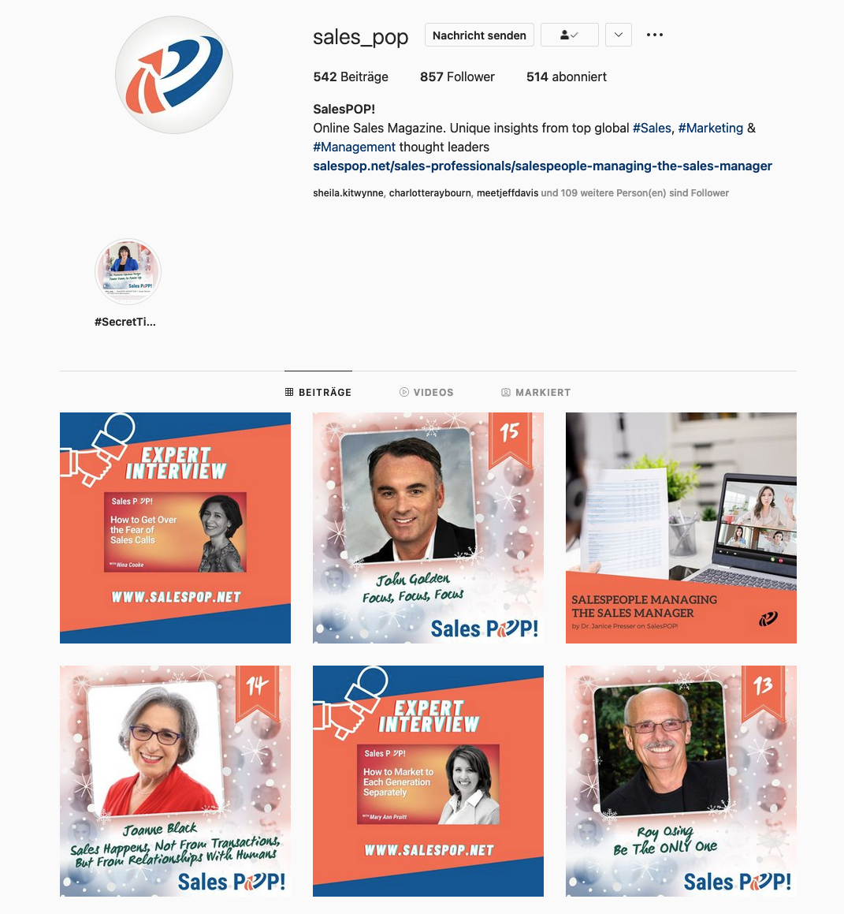

Photo by Martha Neumeister, <https://www.instagram.com/sales_pop/>

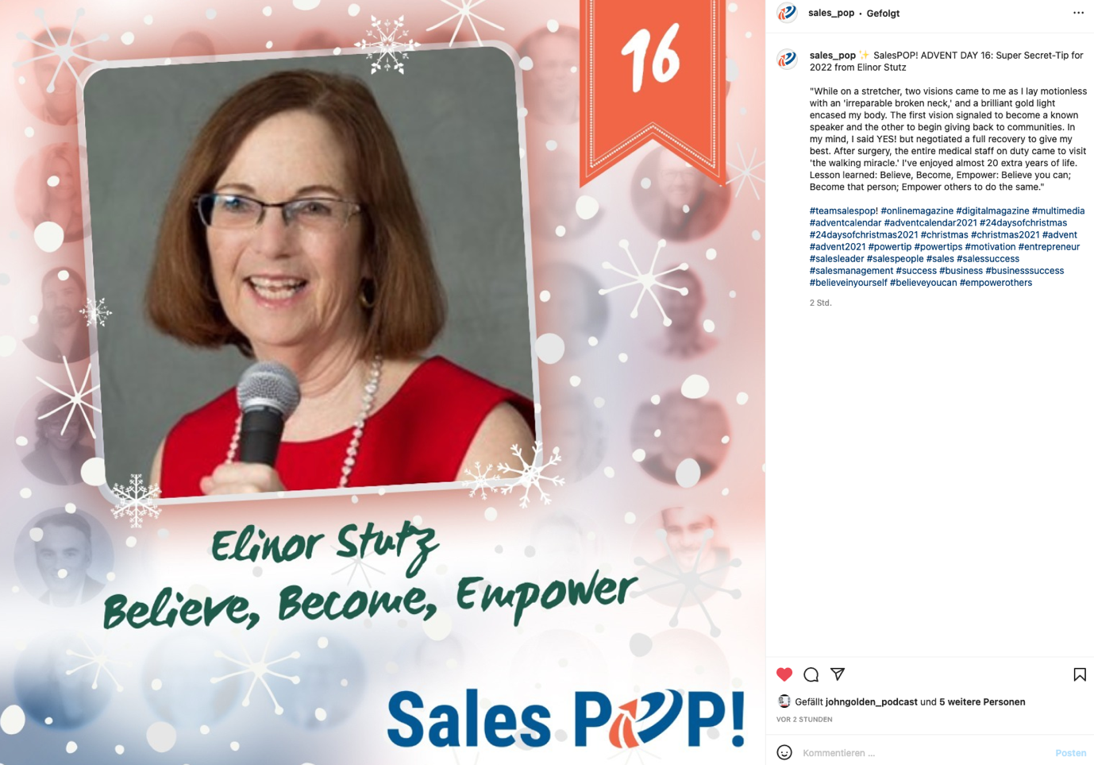

Photo by Martha Neumeister, <https://www.instagram.com/sales_pop/>

**The Organization Behind It**

As you already know, SalesPOP! is an online magazine that continuously provides expert insights into sales and leadership. We are working together with many experts in different fields. We have 963 contributors all over the world. So, we thought, why not ask some of them to share their success tips for 2022 that may assist business people and deliver it over a social media Christmas calendar. The process consists of the following steps:

1) Think about the best social media platform (we decide Instagram)

2) Choose 23 contributors and ask if they are interested in participating through email

3) Create a content calendar that includes:

a) Contributor Name

b) Title of the secret tip

c) Description of the secret tip

d) Date of publication

e) Time of posting

f) Email address of the contributor

g) Checkbox for emailing the details to the contributors

h) Some internal notes

4) Create some graphical templates you can use and then choose the best one

5) Fill out the graphical templates with details

6) Use your social media management tool to schedule each tip

7) Upon publication, share the Instagram link on all social media channels, including tagging the experts

**The Idea Behind It**

Wouldn't it be great if a crystal ball were available that would make you more successful in your sales, marketing, or business efforts? Or if there would be one secret you could do to boost your success?

Well, there is no crystal ball to tell you the bad news. Success, in general, is hard work. It needs flexibility, good planning, and organizational skills. So, there is no shortcut to success.

It is getting more challenging to create and sustain a business with every passing day. While there is no magic formula for reaching success, there are many things you can do that will help you boost your business performance. Whether you are in sales, marketing, or running a business, start thinking about your new year's resolution now and use these 23 tips from proven experts as a roadmap to your success! What worked a while ago may not work right now or is not relevant anymore, and therefore it is high time to change.

**Why Are We Doing This**

Traditional Education was yesterday!

In the past, what you learned today you could immediately apply tomorrow. But today, the changes are so quick that people need to go through many educational models that have no connection to the practical skills they need for success. The natural force of learning is a combination of real-world experience.

Our CEO [Nikolaus Kimla](https://www.linkedin.com/in/nikolauskimla/) said: "Education will be effective when it can provide its recipients with knowledge applicable across many different fields. It is why we are providing Education that helps people think outside the box and develop problem-solving mindsets."

That is why it was our effort to begin focusing on content. Under content, we mean meaningful content that helps people be successful in business and life. And this is an essential part of our business model, "**Win Together**": Providing valuable learnings to support people worldwide to achieve their business and personal targets and vice versa to be examples for others to do the same.

If you like what you've read and want to use the expert tips for your business, then visit SalesPOP! on [Instagram](https://www.instagram.com/sales_pop/), and don't forget to check back each day to see the latest one!

**So go ahead, Sell More, Spread Peace!**

P.s: We also created a social media Christmas calendar for Pipeliner CRM. If you are interested in getting 24 super feature tips for using our CRM, you may want to visit [Pipeliner](https://www.instagram.com/pipelinercrm/" \t "_blank) on Instagram too :-)

**Sales Tips: 23 Secret Tips To Boost Success**

1. Use the Holiday spirit to share your best.
2. Continue sharing your best throughout the year.
3. Feel the goodwill and then the excellent spirit returning the favor.
4. Be thankful for all you have and offer help to those in need.
5. Share your best insights for others also to succeed.
6. Learn from everyone, including the not-so-good and the excellent lessons.
7. Revise what is not working as it should improve your outcome.
8. Track all new processes to ensure they work well alone and together.
9. Initiate good cheer and goodwill for others and use the 23 secret tips to boost success.
10. Celebrate Success!